Algorithms, Processes and Data

Logbook

Jack Hurst

# Week 1 & 2

a)

**protected** **void** randomise()

{

//start timer

setUp();

//create an int array and fill it

**int**[] copy = getArray();

//create int j

**int** j;

/*

* this for loop will swap position i and a random position

* */

//for every int in copy

**for**(**int** i : copy)

{

//store a random int in the array

**int** randomPos = getRandomIndex();

//make j equal pos i

j = copy[i];

//make position i of the array equal the one from a random pos

copy[i] = copy[randomPos];

//make a randompos in the array equal the the one in pos i

copy[randomPos] = j;

}

//set the array to equal the new randomised copy

**for** (**int** index = 0; index < getArray().length; index ++)

{

getArray()[index] = copy[index];

}

//end timer

tearDown();

}

b)

//get time at the start

**protected** **void** setUp()

{

*testStart* = System.*nanoTime*();

}

//get time at the end

**protected** **void** tearDown()

{

*testEnd* = System.*nanoTime*();

}

//return the the time in microseconds

**protected** String printTime()

{

String time = "\n" + "Test " + "took " + (*testEnd*-*testStart*)/1000 + " microseconds";

**return** time;

}

Tests:

**public** **class** CleverRandomListingTest **extends** ListingTest

{

**private** **static** **long** *testStart*, *testEnd*;

@BeforeClass

**public** **static** **void** setUpBeforeClass() **throws** Exception {

}

@AfterClass

**public** **static** **void** tearDownAfterClass() **throws** Exception {

}

@Rule **public** TestName testName = **new** TestName();

@Before

**public** **void** setUp() **throws** Exception {

*testStart* = System.*nanoTime*();

}

@After

**public** **void** tearDown() **throws** Exception {

*testEnd* = System.*nanoTime*();

System.***out***.println("Test \"" + testName.getMethodName() + "\" took " + (*testEnd*-*testStart*)/1000 + " microseconds");

}

@Test

**public** **void** testOneSize() {

testSize(1,**new** CleverRandomListing(1));

}

@Test

**public** **void** testOneContents() {

testContents(1,**new** CleverRandomListing(1));

}

@Test

**public** **void** testTwoSize() {

testSize(2,**new** CleverRandomListing(2));

}

@Test

**public** **void** testTwoContents() {

testContents(2,**new** CleverRandomListing(2));

}

@Test

**public** **void** testFourSize() {

testSize(4,**new** CleverRandomListing(4));

}

@Test

**public** **void** testFourContents() {

testContents(4,**new** CleverRandomListing(4));

}

@Test

**public** **void** testHundredSize() {

testSize(100,**new** CleverRandomListing(100));

}

@Test

**public** **void** testHundredContents() {

testContents(100,**new** CleverRandomListing(100));

}

@Test

**public** **void** testThousandContents() {

testContents(1000,**new** CleverRandomListing(1000));

}

@Test

**public** **void** testMillionSize() {

testSize(1000000,**new** CleverRandomListing(1000000));

}

}

Test "testHundredSize" took 37993 microseconds

Test "testOneSize" took 34 microseconds

Test "testHundredContents" took 720 microseconds

Test "testTwoSize" took 27 microseconds

Test "testOneContents" took 26 microseconds

Test "testTwoContents" took 37 microseconds

Test "testThousandContents" took 15724 microseconds

Test "testMillionSize" took 128112 microseconds

Test "testFourSize" took 101 microseconds

Test "testFourContents" took 20 microseconds

# Week 3 & 4

**public** **static** <T> **boolean** equals(T object1,T object2)

{

**if** (object1==**null**)

{

**return** object2==**null**;

}

**else**

{

**return** object1.equals(object2);

}

}

**public** **static** <T> **void** Swap(T[] array,**int** i, **int** j)

{

//Sets two variables to equal the positions I wants to swap

T firstObject = array[i];

T secondObject = array[j];

//Set both positions to equal the stored variables

array[i] = secondObject;

array[j] = firstObject;

}

**public** **static** **void** main(String[] args)

{

//Makes the array which has objects that need swapping

Object[] names = {1,"Andrew",2,"Diane",3,"Simon"};

//Runs the swap method

*Swap*(names, 1, 4);

//Prints to the debug log for testing purposes

System.***out***.println(Arrays.*toString*(names));

}

Results:

[1, 3, 2, Diane, Andrew, Simon]

# Week 5

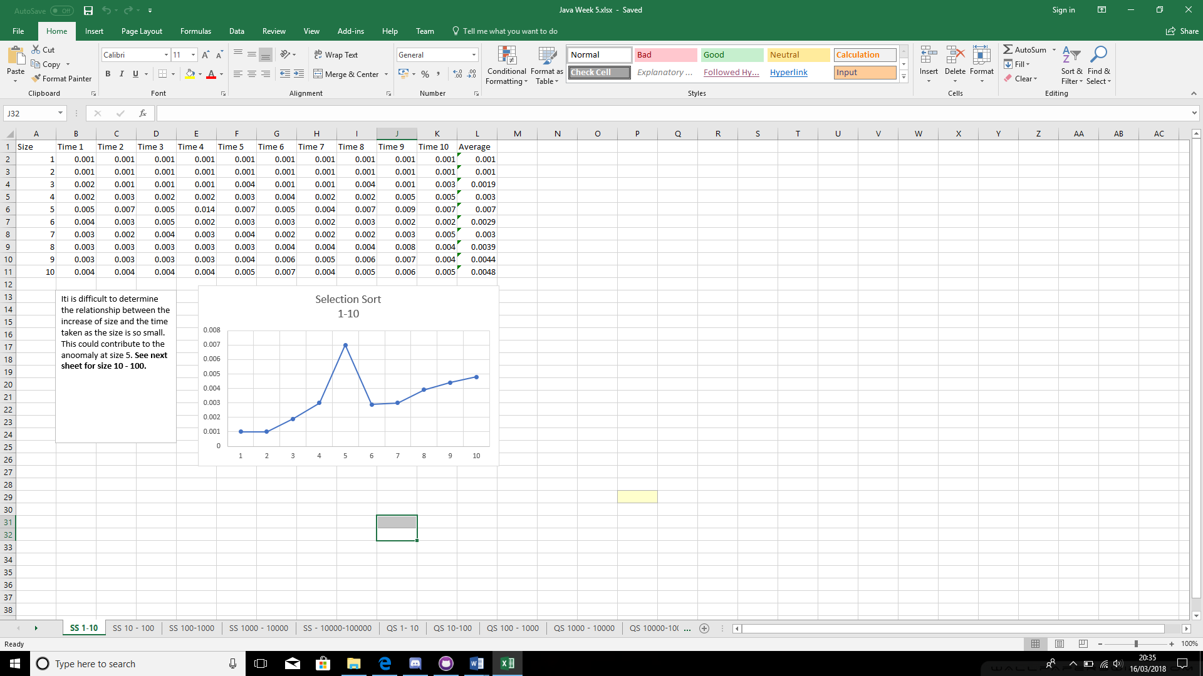

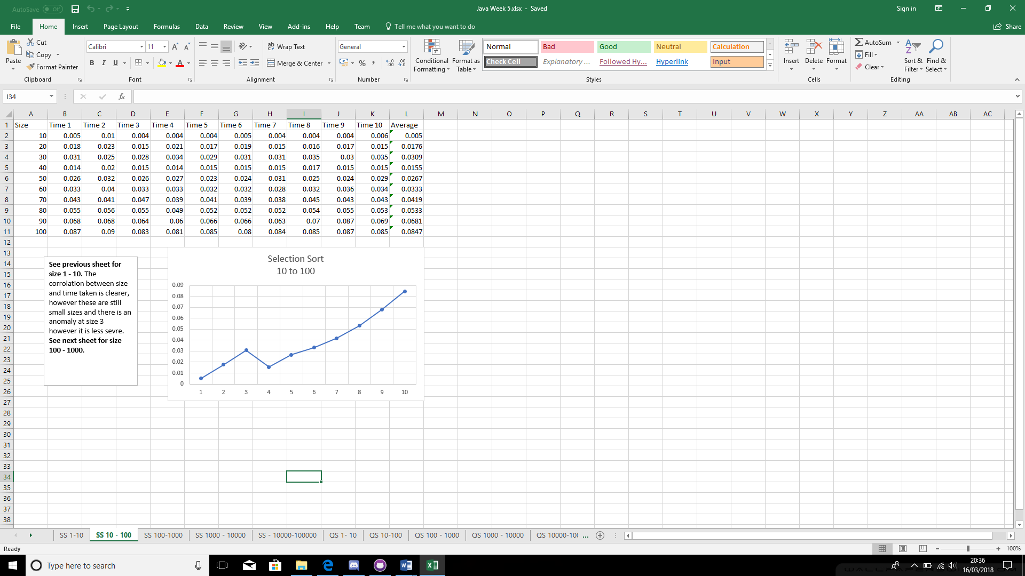

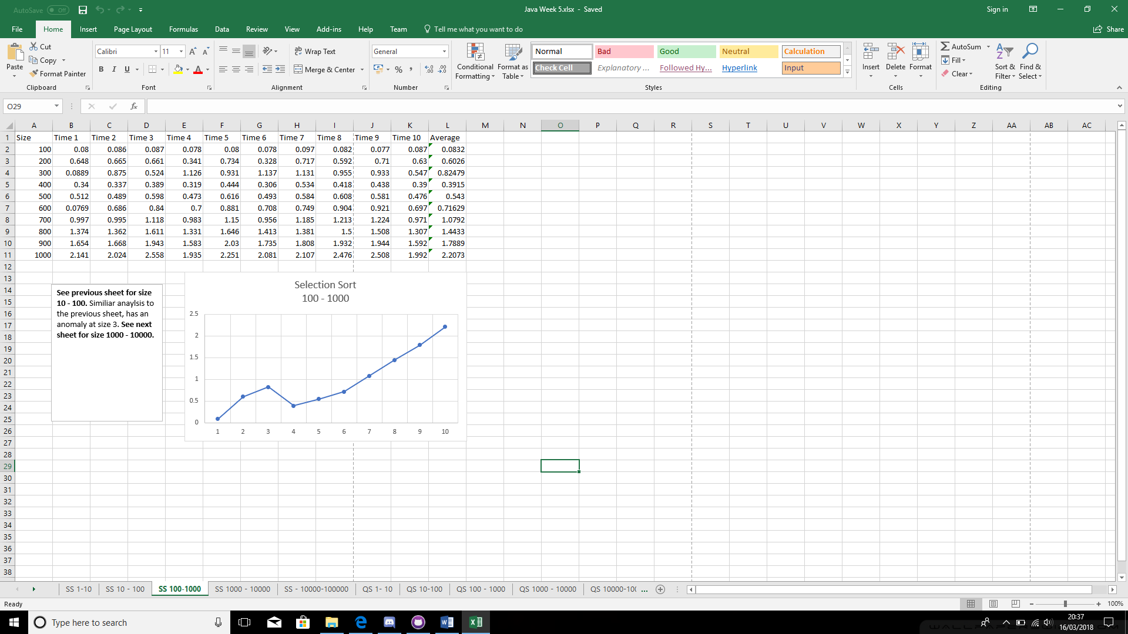

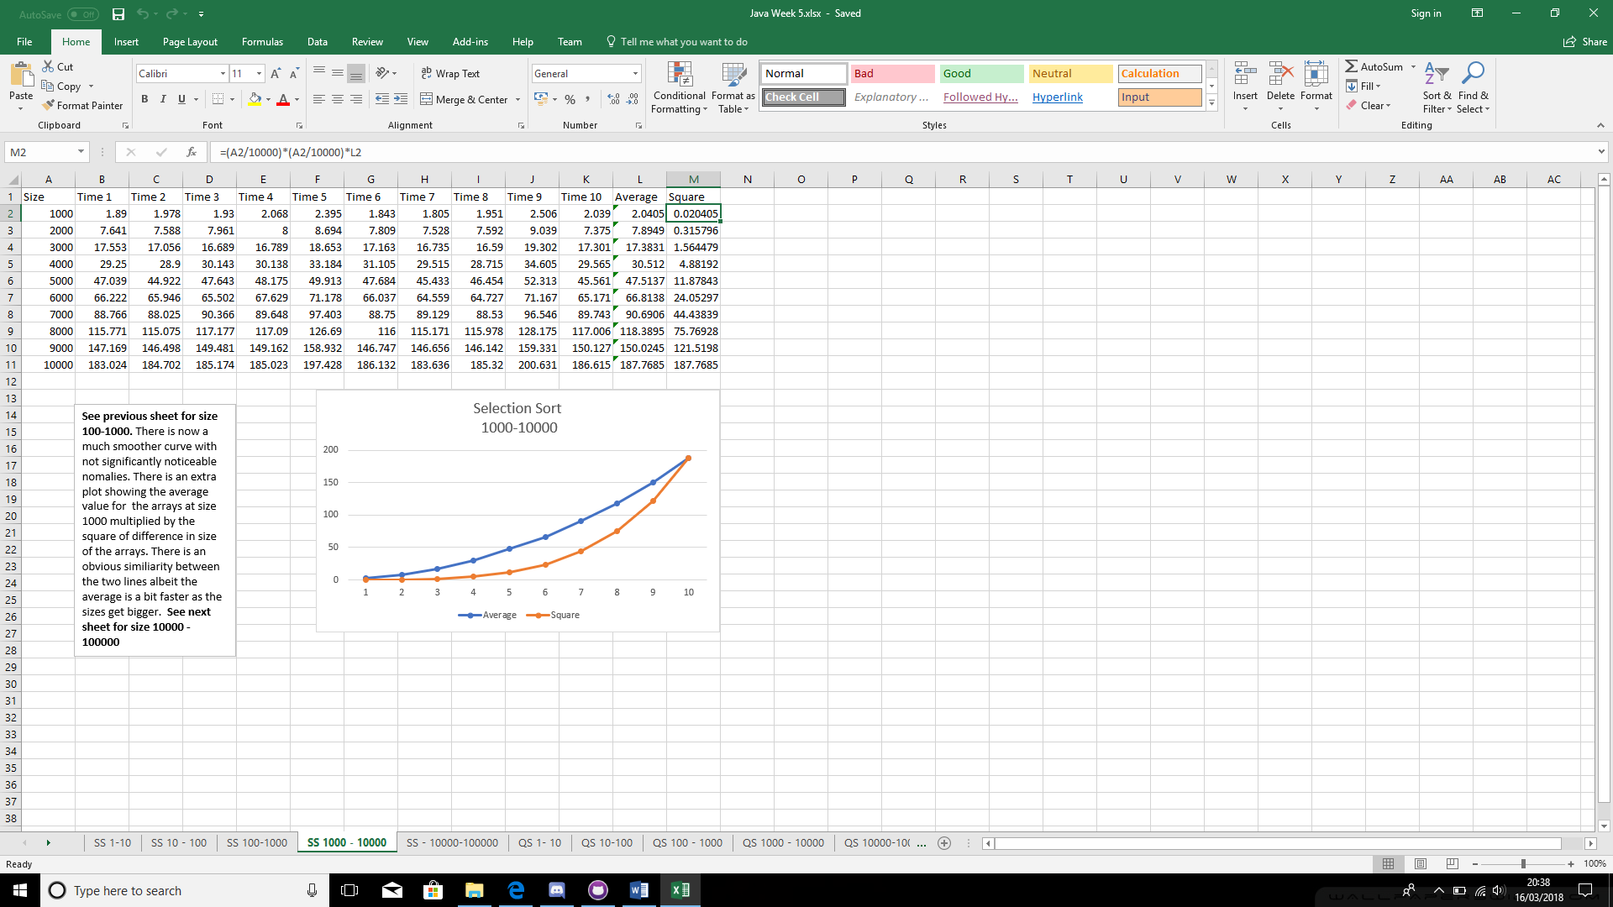

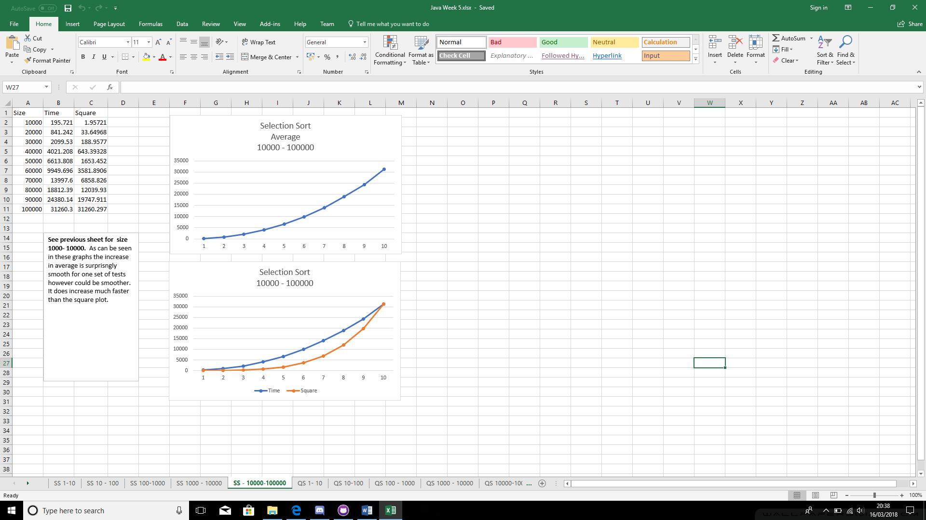

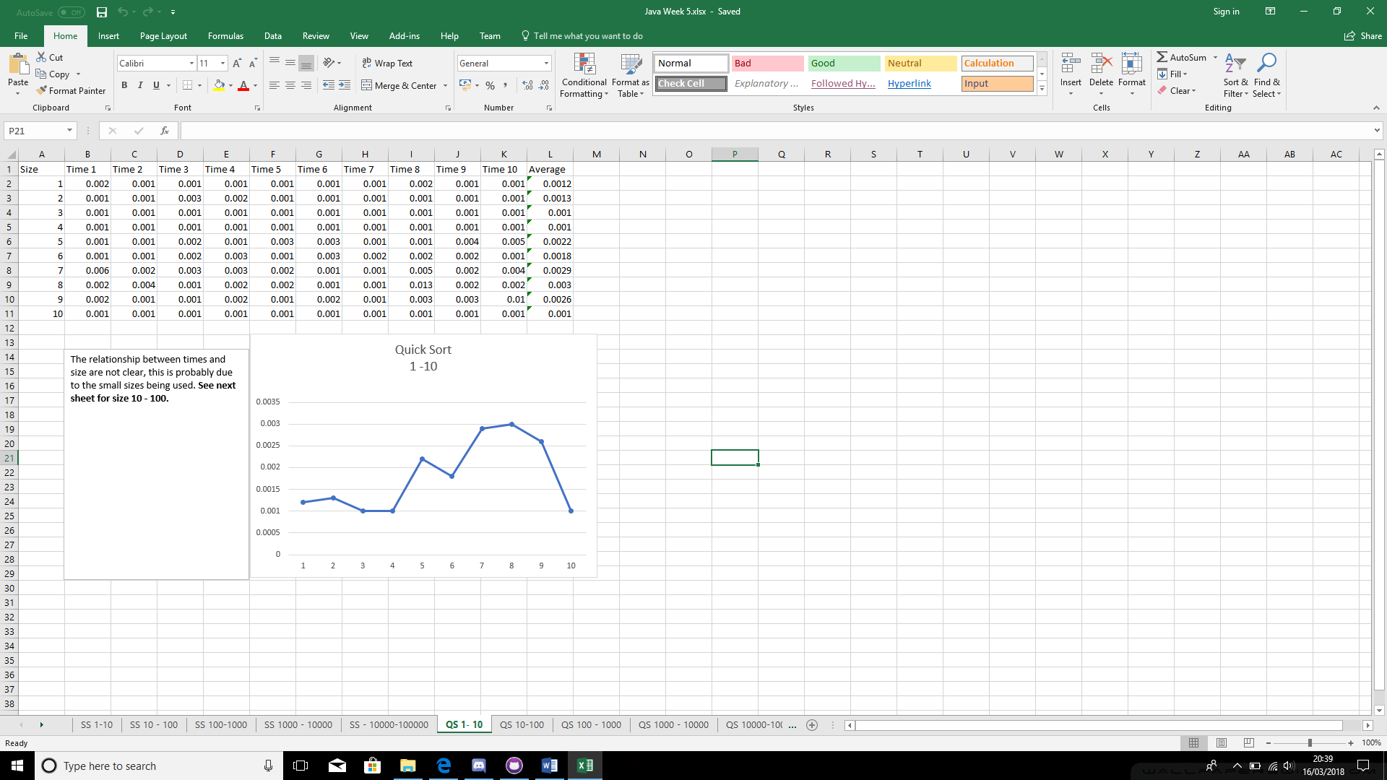

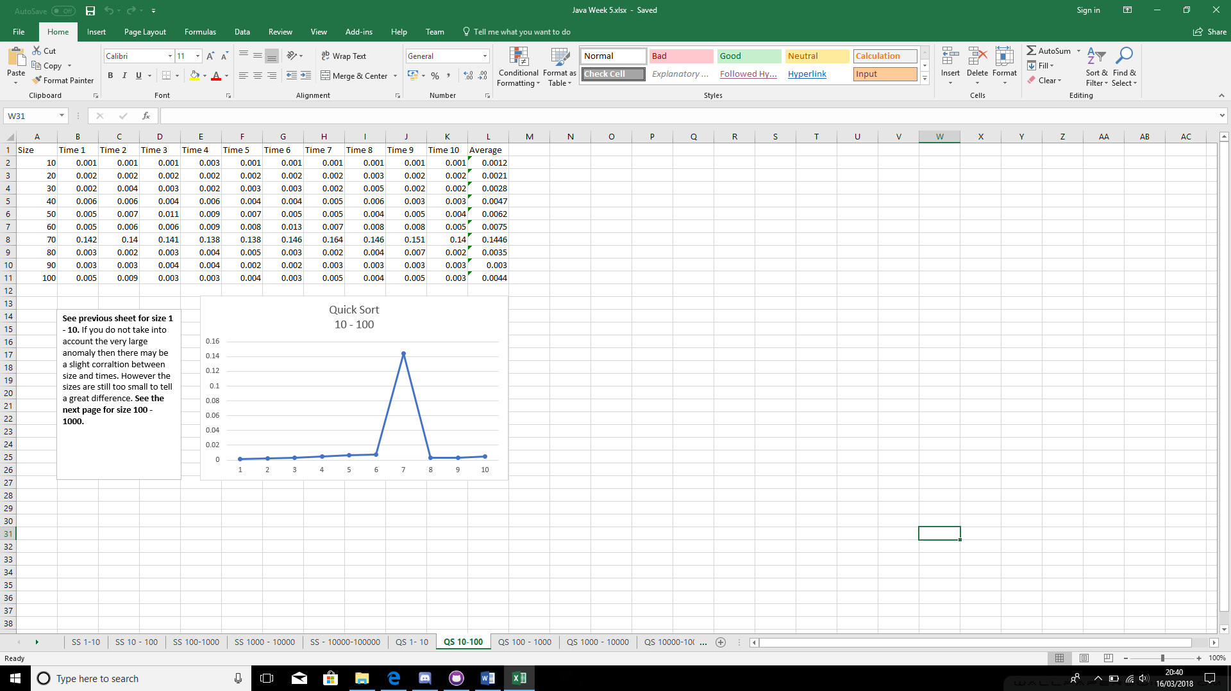

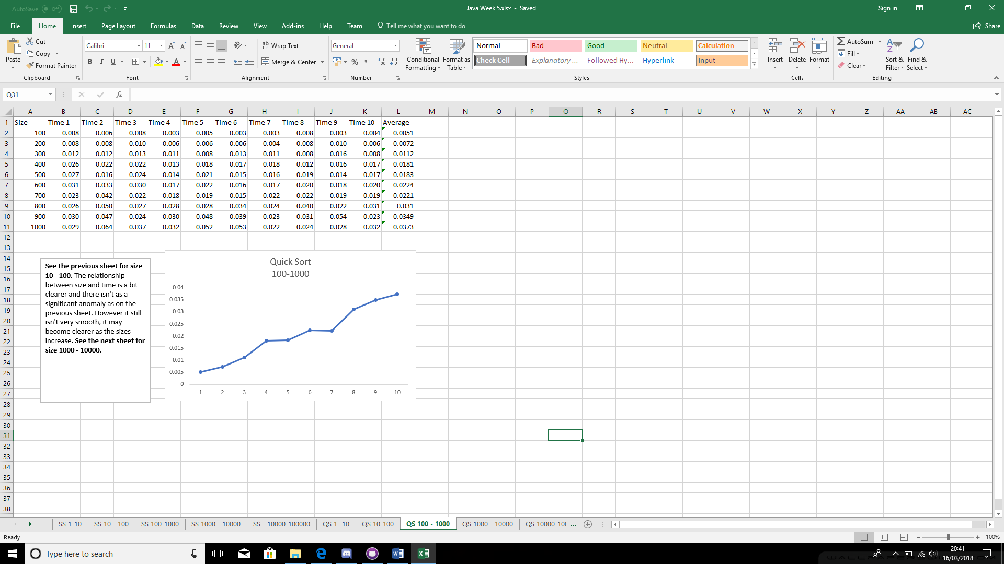

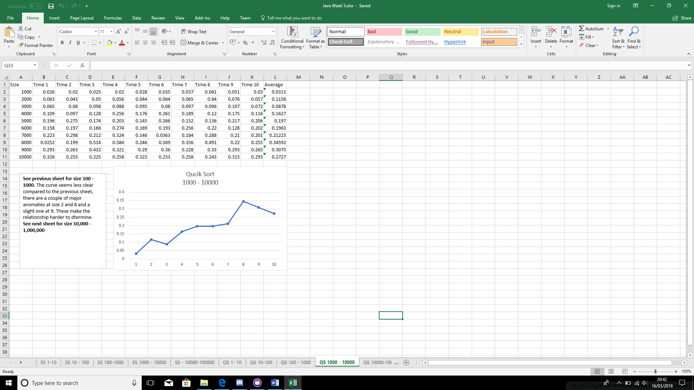

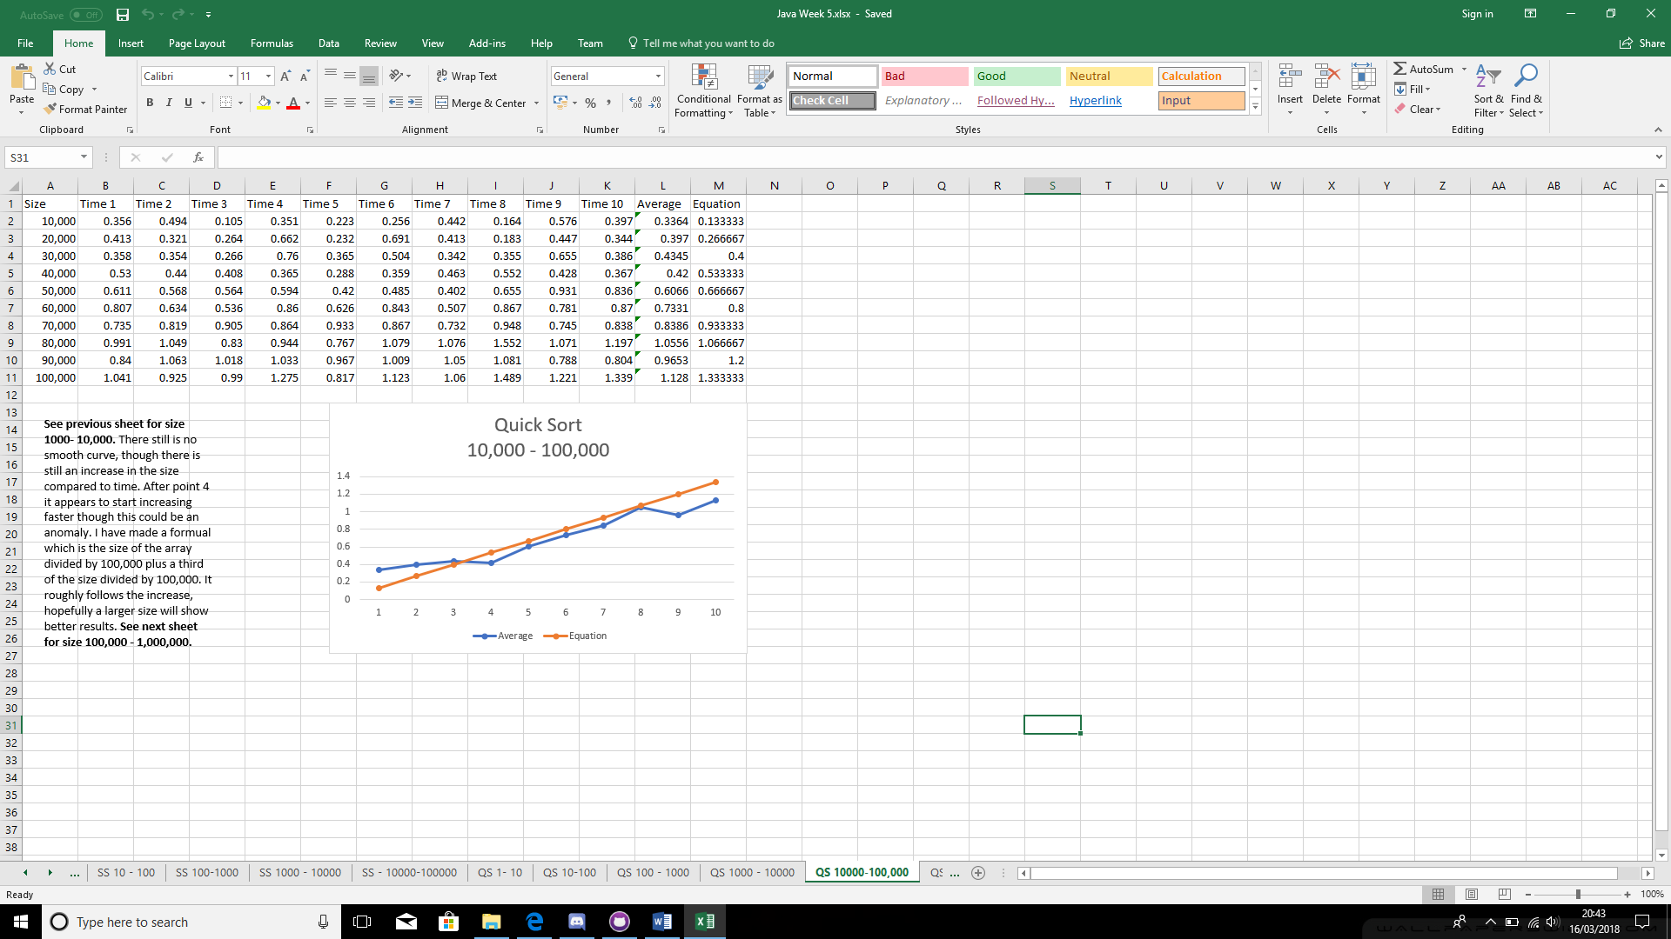

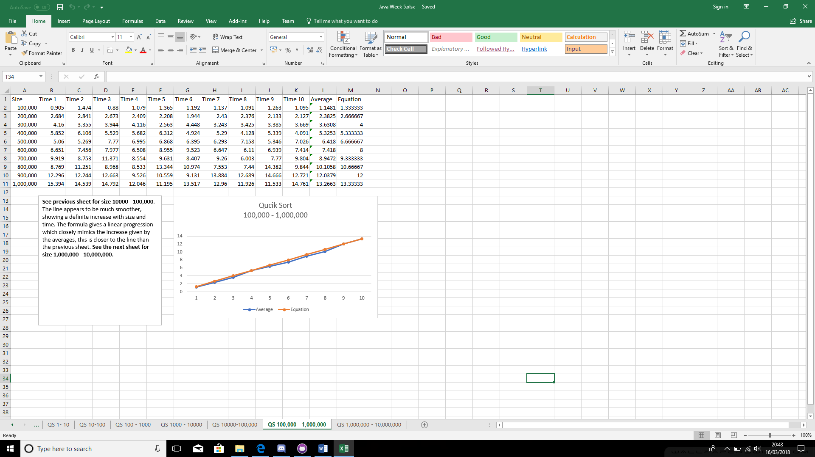

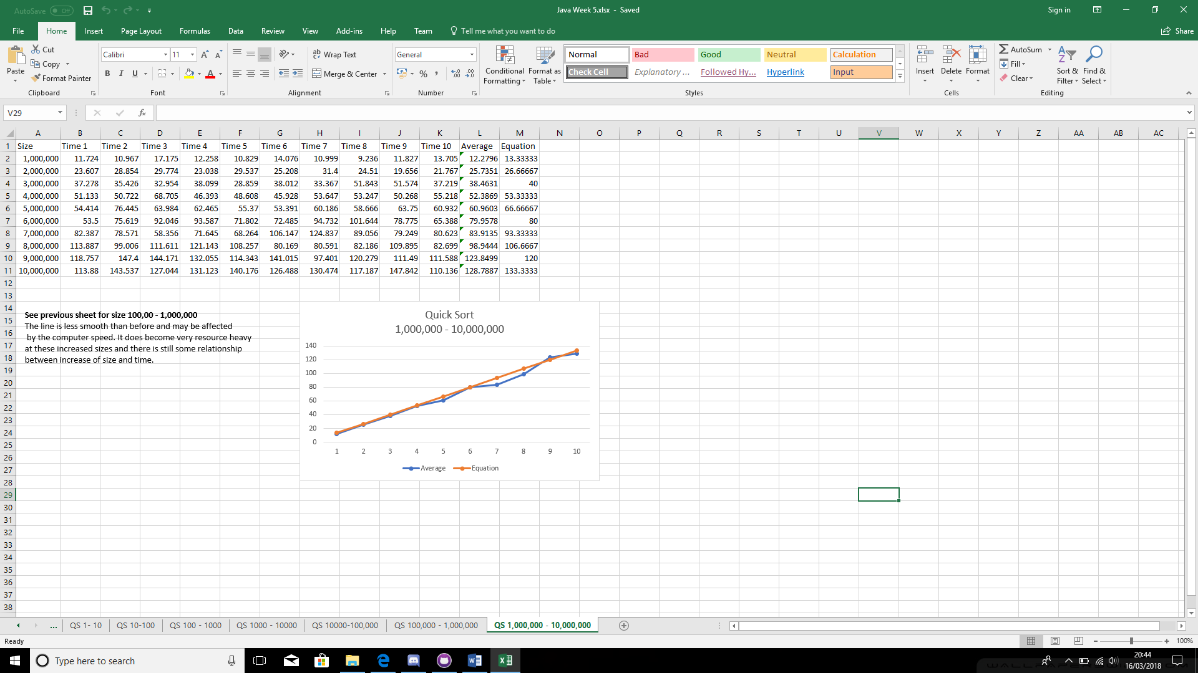

# Week 6

1)

**public** **void** add(**int** index, T value) **throws** ListAccessError

{

//temp node equals the value

Node<T> temp = **new** Node<T>(value);

//if it is empty

**if**(isEmpty())

{

//head is the value

head = temp;

//tail equals what the head did

tail = head;

}

**else**

{

//newNode will be the starting point, the head

Node<T> newNode = head;

**int** i = 1;

//go through the list until you are at the node before the one you want

**while**(i < index)

{

newNode = newNode.getNext();

i++;

}

//set the new node and the one before it

temp.setNext(newNode.getNext());

newNode.setNext(temp);

}

// add to the number of nodes

noOfNodes ++;

}

@Override

**public** T remove(**int** index) **throws** ListAccessError

{

Node<T> temp = head;

//if its node empty

**if**(!isEmpty())

{

**int** i = 1;

//go through the list to the one before you want

**while**(i != index)

{

temp = temp.getNext();

i++;

}

//shift the nodes

temp.setNext(temp.getNext().getNext());

noOfNodes --;

}

**return** **null**;

}

@Override

//get the value of the node at index

**public** T get(**int** index) **throws** ListAccessError

{

**return** getNode(index).getValue();

}

**private** Node<T> getNode(**int** index) **throws** ListAccessError

{

**if** (index < 0 || index >= noOfNodes)

{ // invalid index

**throw** **new** ListAccessError("Index out of bounds");

}

Node<T> node = head; // start at head of list

**for** (**int** i = 0; i < index; i++)

{ // walk through list to desired index

node = node.getNext(); // by following next references

}

**return** node; // return the node at the required index

}

2)

@Test

**public** **void** randomArrayTestLow() **throws** ListAccessError

{

**long** startTime = System.*nanoTime*();

SinglyLinkedLists<Integer> list = **new** SinglyLinkedLists<Integer>();

RandomIntegerArray rand = **new** RandomIntegerArray(500);

Integer[] temp = rand.randomArray(500);

**for**(**int** i = 0; i < temp.length; i++)

{

list.add(i, temp[i].intValue());

}

**long** endTime = System.*nanoTime*();

System.***out***.println("Array Position: " + temp[375].toString() + " List Position: " + list.get(375) + " Time Taken in Microseconds: " + (endTime-startTime)/10000);

*assertEquals*(temp[375],list.get(375));

}

Result:

Array Position: 174 List Position: 174 Time Taken in Microseconds: 61

@Test

**public** **void** randomArrayTestHigh() **throws** ListAccessError

{

**long** startTime = System.*nanoTime*();

SinglyLinkedLists<Integer> list = **new** SinglyLinkedLists<Integer>();

RandomIntegerArray rand = **new** RandomIntegerArray(50000);

Integer[] temp = rand.randomArray(50000);

**for**(**int** i = 0; i < temp.length; i++)

{

list.add(i, temp[i].intValue());

}

**long** endTime = System.*nanoTime*();

System.***out***.println("Array Position: " + temp[4756].toString() + " List Position: " + list.get(4756) + " Time Taken in Microseconds: " + (endTime-startTime)/10000);

*assertEquals*(temp[4756],list.get(4756));

}

Result:

Array Position: 31283 List Position: 31283 Time Taken in Microseconds: 220797

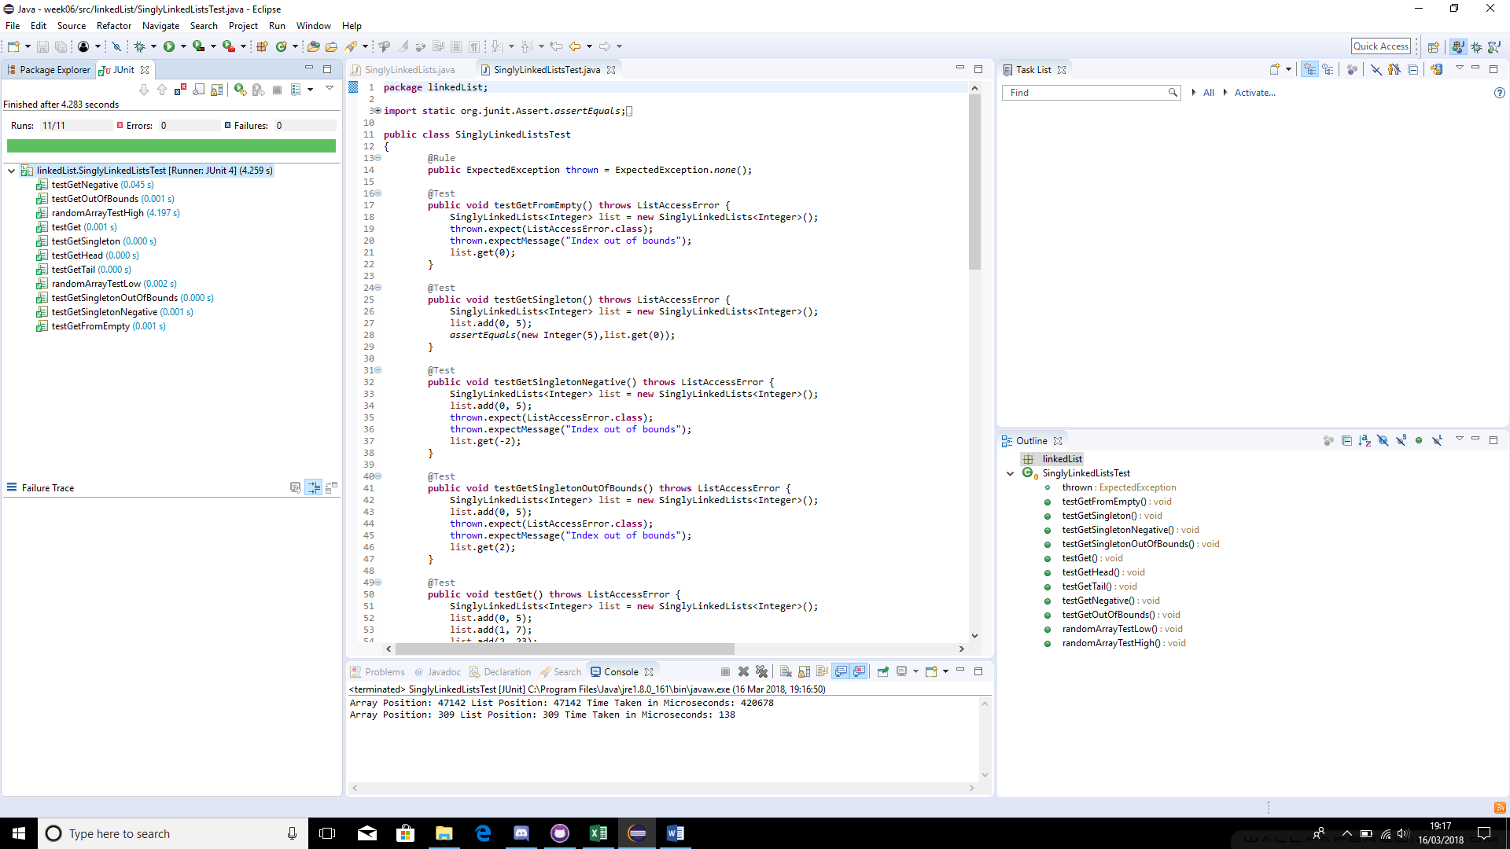

# Week 8

**public** **class** BinaryTree<T **extends** Comparable<? **super** T>> **implements** BTree<T>

{

TreeNode<T> root;

@Override

**public** **void** insert(T value)

{

//if the rool is empty

**if**(root==**null**)

{

//Add the new node to the root

root = **new** TreeNode<T>(value);

}

//if the value compared to the root is less than zero (it's smaller than the root)

**else** **if**(value.compareTo(value())<0)

{

//move to the left node, try insert again

root.left().insert(value);

}

**else**

{

//move to the right node, try insert again

root.right().insert(value);

}

}

//Get root value

@Override

**public** T value()

{

**return** root.value;

}

//Get value of the left node

@Override

**public** BTree<T> left()

{

**return** root.left;

}

//Get value of the right node

@Override

**public** BTree<T> right()

{

**return** root.right;

}

**public** **static** **void** main(String args[])

{

{

BinaryTree<Integer> tree = **new** BinaryTree<>();

tree.insert(1);

tree.insert(2);

tree.insert(3);

tree.insert(-1);

Integer leftV = tree.left().value();

Integer rightV = tree.right().value();

Integer rightRightV = tree.right().right().value();

System.***out***.println(tree.value());

System.***out***.println(leftV);

System.***out***.println(rightV);

System.***out***.println(rightRightV);

}

}

Results:

1

-1

2

3

# Self-Assessment Week 1 – 8

|  |  |  |  |  |  |  |
| --- | --- | --- | --- | --- | --- | --- |
| **Week** | **Overall** | **Docs** | **Struct** | **Names** | **Tests** | **Funct** |
| **1 & 2**  **Search timer** | B | C | B | B | C | B |
| **3 & 4**  **Generic swap** | B | B | B | B | C | B |
| **5**  **Sorting** | B+ | A | B | B | A | B |
| **6**  **Linked lists** | B+ | B | B | A | B | B |
| **8**  **Binary trees** | B | B | B | B | C | B |

Evidence/justification:

Week 1 & 2:

The CleverRandomListing performs the task required, the code is commented step by step so another user can see how it works which is shown in the documentation. The structure is easy to read with a simple to understand naming convention, I tested it’s functionality with the timer multiple times and it works as desired. I feel the documentation can look busy and maybe could have done with some of the test results from the test class.

Week 3 & 4:

The Swap class swaps two objects in an array as required, it is generic as it swaps multiple types of objects, I demonstrated ints and strings swapping. I could have done a testing class rather than just a main but it does demonstrate it on a basic level. There are comments in the code to explain what’s happening and I feel the naming was simple.

Week 5:

I have shown many results from the low sizes to high, each sheet having a description of what’s happening. There are formulae to give an indication to how execution times vary to data sizes, however I feel the Quick Sorts algorithm is more original and accurate than the selection sorts.

Week 6:

The names of what the functions do a named clearly with comments, it performs the task which is demonstrated in the test methods, one shows a test with a large array the other shows a test with a small array. These have been shown with the results printed.

Week 8:

It performs the task as needed, could have made a detailed test class, however I have made a mina that shows an example of it working. Could have done a larger test sample. Have included comment, naming is generic and easy to understand.

# Week 9

When the values are added their position is determined by their ascii value of the key % of the size of the table, a formula for this could look like this:

x % n

Where x is the ascii value of the key and the n is the length of the hash table

When adding values to the hash table once the size has reached the threshold the hash tables size increases, the hash tables size seems to increase by its own size by x2 to how many times it has increased. A formula of this is:

X*2^n

Where X is the hash table size starting from 1 and n is the amount of times it has been increased.

# Week 10

**public** **class** DepthFirstTraversal<T> **extends** AdjacencyGraph<T> **implements** Traversal<T>

{

List<T> ourGraph = **new** ArrayList<T>();

List<T> visited = **new** ArrayList<T>();

@Override

**public** List<T> traverse() **throws** GraphError

{

**for**(**int** i = 0; i<getNodes().size(); i++)

{

//If we have not visited all the nodes

**if**(visited.size() <getNodes().size())

{

//store our current node

@SuppressWarnings("unchecked")

T startNode = (T) getNodes().toArray()[i];

//If our visited array does not contain this node

**if**(!visited.contains(startNode))

{

recursiveDepthFirstTraversal(startNode);

}

}

**else** **break**;

}

**return** ourGraph;

}

**public** **void** recursiveDepthFirstTraversal(T node) **throws** GraphError

{

//Add our node to the visited list and our graph

visited.add(node);

ourGraph.add(node);

//set what the neighbours are

Set<T> neighboursSet = getNeighbours(node);

//put the neighbours into an object array

@SuppressWarnings("unchecked")

T[] neighbouringNodes = (T[]) neighboursSet.toArray();

//check through all the neighbouring nodes

**for** (**int** i = 0; i < neighbouringNodes.length; i++)

{

//this node is the current neighbour

T n = neighbouringNodes[i];

// if it is not visited and exists

**if** (n != **null** && !visited.contains(n))

{

//start again from here

recursiveDepthFirstTraversal(n);

}

}

}

**public** **static** **void** main(String[] args) **throws** GraphError

{

DepthFirstTraversal<Integer> graph = **new** DepthFirstTraversal<>();

Integer node0 = **new** Integer(0);

Integer node1 = **new** Integer(1);

Integer node2 = **new** Integer(2);

Integer node3 = **new** Integer(3);

Integer node4 = **new** Integer(4);

graph.add(node0);

graph.add(node1);

graph.add(node2);

graph.add(node3);

graph.add(node4);

graph.add(0, 3);

graph.add(0, 2);

graph.add(1, 0);

graph.add(2, 1);

graph.add(3, 4);

graph.add(4,0);

graph.traverse();

System.***out***.println("Recursive Depth First Traversal: "+Arrays.*toString*((graph.ourGraph.toArray())));

}

}

Results:

Recursive Depth First Traversal: [0, 2, 1, 3, 4]

# Week 11

**public** **class** ReferenceCountTopologicalSort<T> **extends** AdjacencyGraph<T> **implements** TopologicalSort<T>

{

//create our hashmap

HashMap<T, Integer> map = **new** HashMap<T, Integer>();

//create our list for sorted nodes

List<T> sortedNodes = **new** ArrayList<T>();

@Override

**public** List<T> getSort() **throws** GraphError

{

initialise();

setUpReferenceCounts();

addToSort();

System.***out***.println(map);

System.***out***.println(sortedNodes);

**return** sortedNodes;

}

**private** **void** initialise()

{

//add all our empty nodes

**for** (T node : getNodes())

{

map.put(node, 0);

}

}

**private** **void** setUpReferenceCounts() **throws** GraphError

{

//for every object in every node

**for** (T node : getNodes())

{

//for every object in every neighbours node

**for** (T successor : getNeighbours(node))

{

**int** references = map.get(successor);

//if the current neighbour is not null

**if** (map.get(successor) != **null**)

{

//add to our hashmap

map.put(successor, ++references);

}

}

}

}

**public** **void** addToSort() **throws** GraphError

{

//whilst we have not sorted the nodes

**while**(sortedNodes.size() < getNodes().size())

{

**for** (T node : getNodes())

{

//if the node is not null and the value is more than 0

**if** (map.get(node) != **null** &&map.get(node).intValue() == 0)

{

//add to our sorted nodes

sortedNodes.add(node);

//for every neighbour

**for** (T successor : getNeighbours(node))

{

Integer references = map.get(successor);

//if our successor is not null

**if** (references != **null**)

{

//add to our map

map.put(successor, references - 1);

}

}

//remove from our map

map.remove(node);

**break**;

}

}

}

}

**public** **static** **void** main(String[] args) **throws** GraphError

{

ReferenceCountTopologicalSort<Integer> graph = **new** ReferenceCountTopologicalSort<>();

Integer node0 = **new** Integer(0);

Integer node1 = **new** Integer(1);

Integer node2 = **new** Integer(2);

Integer node3 = **new** Integer(3);

Integer node4 = **new** Integer(4);

Integer node5 = **new** Integer(5);

Integer node6 = **new** Integer(6);

Integer node7 = **new** Integer(7);

Integer node8 = **new** Integer(8);

Integer node9 = **new** Integer(9);

graph.add(node0);

graph.add(node1);

graph.add(node2);

graph.add(node3);

graph.add(node4);

graph.add(node5);

graph.add(node6);

graph.add(node7);

graph.add(node8);

graph.add(node9);

graph.add(0, 1);

graph.add(0, 5);

graph.add(1, 7);

graph.add(3, 2);

graph.add(3, 4);

graph.add(3, 8);

graph.add(6, 0);

graph.add(6, 1);

graph.add(6, 2);

graph.add(8, 4);

graph.add(8, 7);

graph.add(9, 4);

graph.getSort();

}

Results:

{}

[3, 6, 0, 1, 2, 5, 8, 7, 9, 4]

# Self-assessment Week 9 – 11

|  |  |  |  |  |  |  |
| --- | --- | --- | --- | --- | --- | --- |
| **Week** | **Overall** | **Docs** | **Struct** | **Names** | **Tests** | **Func** |
| **9 Hashtable** | C | Not applicable. Think about how well you have explained the hashtable’s behaviour | Not applicable. Think about how well you have explained the hashtable’s behaviour | Not applicable. Think about how well you have explained the hashtable’s behaviour | Not applicable. Think about how well you have explained the hashtable’s behaviour | Not applicable. Think about how well you have explained the hashtable’s behaviour |
| **10**  **Depth first**  **traversal** | B | B | B | B | C | B |
| **11**  **Reference**  **counting**  **topological**  **sort** | B | B | B | B | C | B |

Week 9:

I gave a concise description on how hashtables work using formulae I came up with, I tried to explain this in an understandable way.

Week 10:

I feel it fulfils the function required however it lacks thorough evidence of testing, it is fully commented, it is structed clearly and uses a generic naming convention.

Week 11:

Similar to week 10, should have used a test class however does show its test and results. It uses generic naming convention, it is structed clearly and works as intended.

# Week 13

1. The test is not always guaranteed to terminate. The test could theoretically always count between the two finishing points meaning it never reaches the end, though this is unlikely
2. The shortest amount of lines that can be achieved is 14, this is due to the counter starting at a finishing point, recognising this then counting up/down to the other finish point.
3. The largest number the counter can reach is 11, this is because it starts at 10 then immediately adds one.
4. The lowest possible number the counter can reach is -1 this happens when it starts as 0 and immediately counts down.

# Week 14

**public** **void** runTrain() **throws** RailwaySystemError

{

Clock clock = getRailwaySystem().getClock();

Railway nextRailway = getRailwaySystem().getNextRailway(**this**);

**while** (!clock.timeOut())

{

//start

choochoo();

//put a stone in my current track

getBasket().putStone(**this**);

// whilst the other track has a stone

**while** (nextRailway.getBasket().hasStone(**this**))

{

//if we both have a stone

**if**(nextRailway.getBasket().hasStone(**this**) == getBasket().hasStone(**this**))

{

//pick up my stone so they can pass

getBasket().takeStone(**this**);

// They have not taken their stone so wait

**while**(nextRailway.getBasket().hasStone(**this**)

!= getBasket().hasStone(**this**))

siesta();

//put the stone back, they're on the track

getBasket().putStone(**this**);

}

}

//change track

crossPass();

}

}

Test results:

Clock: tick tock

Peru: choo-choo

Bolivia: choo-choo

Peru: adding stone to Peru's basket (0 stones in the basket)

Bolivia: adding stone to Bolivia's basket (0 stones in the basket)

Peru: checking Bolivia's basket for stones

Bolivia: checking Peru's basket for stones

Peru: checking Bolivia's basket for stones

Bolivia: checking Peru's basket for stones

Peru: checking Peru's basket for stones

Bolivia: checking Bolivia's basket for stones

Clock: tick tock

Peru: removing stone from Peru's basket (1 stone in the basket)

Peru: checking Bolivia's basket for stones

Bolivia: removing stone from Bolivia's basket (1 stone in the basket)

Peru: checking Peru's basket for stones

Bolivia: checking Peru's basket for stones

Peru: zzzzz

Peru: checking Bolivia's basket for stones

Bolivia: checking Bolivia's basket for stones

Peru: checking Peru's basket for stones

Bolivia: adding stone to Bolivia's basket (0 stones in the basket)

Clock: tick tock

Bolivia: checking Peru's basket for stones

Peru: adding stone to Peru's basket (0 stones in the basket)

Bolivia: entering pass

Bolivia: crossing pass

Bolivia: leaving pass

Bolivia: choo-choo

Peru: checking Bolivia's basket for stones

Bolivia: adding stone to Bolivia's basket (1 stone in the basket)

Peru: checking Bolivia's basket for stones

Bolivia: checking Peru's basket for stones

Peru: checking Peru's basket for stones

Clock: tick tock

Bolivia: checking Peru's basket for stones

Peru: removing stone from Peru's basket (1 stone in the basket)

Bolivia: checking Bolivia's basket for stones

Peru: checking Bolivia's basket for stones

Bolivia: removing stone from Bolivia's basket (2 stones in the basket)

Peru: checking Peru's basket for stones

Peru: zzzzz

Bolivia: checking Peru's basket for stones

Peru: checking Bolivia's basket for stones

Bolivia: checking Bolivia's basket for stones

Clock: tick tock

Peru: checking Peru's basket for stones

Bolivia: zzzzz

Peru: zzzzz

Bolivia: checking Peru's basket for stones

Peru: checking Bolivia's basket for stones

Bolivia: checking Bolivia's basket for stones

Peru: checking Peru's basket for stones

Bolivia: zzzzz

Peru: zzzzz

Bolivia: checking Peru's basket for stones

Peru: checking Bolivia's basket for stones

Clock: tick tock

Peru: checking Peru's basket for stones

Bolivia: checking Bolivia's basket for stones

Peru: zzzzz

Bolivia: zzzzz

Peru: checking Bolivia's basket for stones

Bolivia: checking Peru's basket for stones

Bolivia: checking Bolivia's basket for stones

Peru: checking Peru's basket for stones

Bolivia: zzzzz

Peru: zzzzz

Clock: tick tock

Bolivia: checking Peru's basket for stones

Peru: checking Bolivia's basket for stones

Bolivia: checking Bolivia's basket for stones

Peru: checking Peru's basket for stones

Peru: zzzzz

Bolivia: zzzzz

Peru: checking Bolivia's basket for stones

Bolivia: checking Peru's basket for stones

Clock: tick tock

Peru: checking Peru's basket for stones

Bolivia: checking Bolivia's basket for stones

Peru: zzzzz

Bolivia: zzzzz

Peru: checking Bolivia's basket for stones

Bolivia: checking Peru's basket for stones

Peru: checking Peru's basket for stones

Bolivia: checking Bolivia's basket for stones

Bolivia: zzzzz

Peru: zzzzz

Peru: checking Bolivia's basket for stones

Bolivia: checking Peru's basket for stones

Clock: tick tock

Peru: checking Peru's basket for stones

Bolivia: checking Bolivia's basket for stones

Peru: zzzzz

Bolivia: zzzzz

Peru: checking Bolivia's basket for stones

Bolivia: checking Peru's basket for stones

Peru: checking Peru's basket for stones

Bolivia: checking Bolivia's basket for stones

Clock: tick tock

Peru: zzzzz

Bolivia: zzzzz

Bolivia: checking Peru's basket for stones

Peru: checking Bolivia's basket for stones

Peru: checking Peru's basket for stones

Bolivia: checking Bolivia's basket for stones

Peru: zzzzz

Bolivia: zzzzz

Peru: checking Bolivia's basket for stones

Peru: checking Peru's basket for stones

Clock: tick tock

Bolivia: checking Peru's basket for stones

Peru: zzzzz

Bolivia: checking Bolivia's basket for stones

Peru: checking Bolivia's basket for stones

Bolivia: zzzzz

Peru: checking Peru's basket for stones

Bolivia: checking Peru's basket for stones

Peru: zzzzz

Clock: tick tock

Bolivia: checking Bolivia's basket for stones

Peru: checking Bolivia's basket for stones

Bolivia: zzzzz

Peru: checking Peru's basket for stones

Bolivia: checking Peru's basket for stones

Peru: zzzzz

Bolivia: checking Bolivia's basket for stones

Peru: checking Bolivia's basket for stones

Peru: checking Peru's basket for stones

Bolivia: zzzzz

Clock: tick tock

Peru: zzzzz

Bolivia: checking Peru's basket for stones

Peru: checking Bolivia's basket for stones

Bolivia: checking Bolivia's basket for stones

Bolivia: zzzzz

Peru: checking Peru's basket for stones

Bolivia: checking Peru's basket for stones ----- This is ongoing

# Week 15

1)

**public** **T** **get**() **throws** **BufferError**, **SemaphoreLimitError** {

**T** **item**;

**try** {

criticalSection.poll(); // is the buffer available?

noOfElements.poll(); // is there at least one data item in the buffer?

// criticalSection.poll(); // is the buffer available?

item = getItem(); // add the data item

criticalSection.vote(); // make the buffer available again

noOfSpaces.vote(); // there is now one more space in the buffer

} **catch** (**InterruptedException** **ie**) {

**throw** **new** BufferError("Buffer: Data item could not be retrieved from the buffer.\n" +

"\t" + ie.getMessage());

}

**return** item;

}

Swapping the order of the criticalSection.poll() and the noOfElements.poll() causes an error situation

2) The error occurs as there are no permits available, so the Semaphore waits until one is available, which never occurs so it just stops after the 20 seconds as it is set to do. The original code starts with permits available, so it can proceed.

|  |  |  |  |  |
| --- | --- | --- | --- | --- |
| Put | Get | noOfSpaces | noOfElements | criticalSection |
|  |  | 10 | 0 | 1 |
|  | Critsec.poll() | 10 | 0 | 0 |
| noOfSpaces() |  | 9 | 0 | 0 |
| Critsec.poll() |  | 9 | 0 | 0 |
| END |  |  |  |  |

|  |  |  |  |  |
| --- | --- | --- | --- | --- |
| Put | Get | noOfSpaces | noOfElements | criticalSection |
|  |  | 10 | 0 | 1 |
|  | noOfElements.poll() | 10 | 0 | 1 |
| noOfSpaces() |  | 9 | 0 | 1 |
| Critsec.poll() |  | 9 | 0 | 0 |
| Critsec.vote() |  | 9 | 0 | 1 |
| noOfElements() |  | 9 | 1 | 1 |
|  | Critsec.poll() | 9 | 0 | 0 |
|  | Critsec.vote() | 9 | 0 | 1 |
|  | noOfSpaces.vote() | 10 | 0 | 1 |

3) It is not essential in the put() as shown in the table below.

|  |  |  |  |  |
| --- | --- | --- | --- | --- |
| Put | Get | noOfSpaces | noOfElements | criticalSection |
|  |  | 10 | 0 | 1 |
|  | noOfElements.poll() | 10 | 0 | 1 |
| Critsec.poll() |  | 10 | 0 | 0 |
| noOfSpaces() |  | 9 | 0 | 0 |
| Critsec.vote() |  | 9 | 0 | 1 |
| noOfElements() |  | 9 | 1 | 1 |
|  | Critsec.poll() | 9 | 0 | 0 |
|  | Critsec.vote() | 9 | 0 | 1 |
|  | noOfSpaces.vote() | 10 | 0 | 1 |

# Week 16

**public** **class** LockResourceManager **extends** BasicResourceManager

{

//new lock

**final** Lock lock = **new** ReentrantLock();

//create our array of conditions for each priority

**final** Condition[] conditions = **new** Condition[11]; //lock.newCondition();

**boolean** inUse = **false**;

**public** LockResourceManager(Resource resource, **int** maxUses)

{

**super**(resource, maxUses);

//initialise our conditions array

**for**(**int** i = 0; i < conditions.length; i++)

{

conditions[i] = lock.newCondition();

}

}

**public** **void** requestResource(**int** priority) **throws** ResourceError

{

lock.lock();

**try**

{

//if our resource is inuse

**if**(inUse)

{

//add to the number waiting

increaseNumberWaiting(priority);

//wait until resource is free

conditions[priority].await();

}

// resource is in use

inUse = **true**;

} **catch** (InterruptedException e) {

e.printStackTrace();

}

**finally**

{

lock.unlock();

}

}

**public** **int** releaseResource() **throws** ResourceError

{

lock.lock();

**try**

{

**for**(**int** i = 10; i >= 0; i--)

{

//if anything is waiting

**if**(getNumberWaiting(i) > 0)

{

//decrease the number waiting

decreaseNumberWaiting(i);

//signal to tell user it can stop waiting

conditions[i].signal();

//resource is no longer in use

inUse = **false**;

//return our user

**return** i;

}

}

//not in use

inUse = **false**;

//no one is waiting

**return** ***NONE_WAITING***;

}

**finally**

{

lock.unlock();

}

}

}

**public** **void** test4_1() **throws** ResourceError

{

ResourceSystem resource1 = **new** ResourceSystem();

// The resource - may be used up to 20 times

resource1.addResource("A", 20);

// User 1 uses the resource for up to 1/10 second each time

resource1.addUser("1",0.1);

// User 2 uses the resource for up to 1/10 second each time

resource1.addUser("2",0.1);

// User 3 uses the resource for up to 1/5 second each time

resource1.addUser("3",0.2);

// User 4 uses the resource for up to 1/5 second each time

resource1.addUser("4",0.2);

resource1.run();

}

Results:

Starting Process "1" (priority: 0)

Starting Process "4" (priority: 0)

Starting Process "2" (priority: 0)

Starting Process "3" (priority: 0)

Process "1" (priority: 5) is requesting resource "A"

Process "4" (priority: 6) is requesting resource "A"

Process "1" (priority: 5) gained access to resource "A"

Process "2" (priority: 2) is requesting resource "A"

1 is using resource "A"

Process "3" (priority: 1) is requesting resource "A"

1 has finished using resource "A"

resource "A" has 5 uses left

Process "1" (priority: 5) released resource "A", to a process with priority 6

Process "4" (priority: 6) gained access to resource "A"

4 is using resource "A"

4 has finished using resource "A"

resource "A" has 4 uses left

Process "4" (priority: 6) released resource "A", to a process with priority 2

Process "2" (priority: 2) gained access to resource "A"

2 is using resource "A"

Process "4" (priority: 3) is requesting resource "A"

2 has finished using resource "A"

resource "A" has 3 uses left

Process "2" (priority: 2) released resource "A", to a process with priority 3

Process "4" (priority: 3) gained access to resource "A"

4 is using resource "A"

Process "2" (priority: 4) is requesting resource "A"

Process "1" (priority: 0) is requesting resource "A"

4 has finished using resource "A"

resource "A" has 2 uses left

Process "4" (priority: 3) released resource "A", to a process with priority 4

Process "2" (priority: 4) gained access to resource "A"

2 is using resource "A"

2 has finished using resource "A"

resource "A" has 1 uses left

Process "2" (priority: 4) released resource "A", to a process with priority 1

Process "3" (priority: 1) gained access to resource "A"

3 is using resource "A"

3 has finished using resource "A"

resource "A" has 0 uses left

Process "3" (priority: 1) released resource "A", to a process with priority 0

Process "1" (priority: 0) gained access to resource "A"

Process "1" (priority: 0) cannot use resource "A" as the resource is exhausted

resource "A" has 0 uses left

Process "1" (priority: 0) released resource "A", there were no waiting processes

Process "1" (priority: 0) has finished

Process "4" (priority: 3) has finished

Process "2" (priority: 4) has finished

Process "3" (priority: 1) has finished

All processes finished

# Self-Assessment Week 13 – 16

|  |  |  |  |  |  |  |
| --- | --- | --- | --- | --- | --- | --- |
| **Week** | **Overall** | **Docs** | **Structure** | **Names** | **Tests** | **Func** |
| **13 Counter Behaviour** | C | N/A | N/A | N/A | N/A | N/A |
| **14 Dekker Trains** | A | B | B | A | A | A |
| **15 Semaphore Behaviour** | A | N/A | N/A | N/A | N/A | N/A |
| **16 Locks and Conditions** | B | B | B | B | B | C |

Week 13:

I did identify important aspects such as the largest and shorted number and shortest length however these did not go into enough detail.

Week 14:

I feel it does what it needs to do effectively, it works every time and I have added the results to the logbook, the names follow the convention set even in the comments which describes step by step, I feel there isn’t much more I could have done.

Week 15:

I feel I went into a good amount of detail with tables to show it’s progression clearly step by step. I think I have demonstrated my strong understanding of semaphores in this work.

Week 16:

I believe it works as intended, the tests are shown clearly, the names are generic, the structure I feel is tidy and it is fully commented.

# Week 17

AND =[

1 1 1 0

0 0 0 1

];

NOT =[

0 1

1 0

];

OR = [

1 0 0 0

0 1 1 1

];

%kron(NOT, AND) = A (Tensor Product of Not & And)

A = [

0,0,0,0,1,1,1,0

0,0,0,0,0,0,0,1

1,1,1,0,0,0,0,0

0,0,0,1,0,0,0,0];

%OR * A = B

B = [

0 0 0 0 1 1 1 0

1 1 1 1 0 0 0 1];

# Week 20

%A is ONE or ZERO

ZERO = [1;0];

ONE = [0;1];

Hadamard = (1/sqrt(2))*[1,1;1,-1];

%Hadamard * ONE = B1

B1 =[0.7071

-0.7071];

%Hadamard * ZERO = B0

B0 =[0.7071

0.7071];

%State C is either of the below

%Hadamard * B1 = ONE

%Hadamard * B0 = ZERO

%If either are these are run through a Hadamard gate twice they return to

%their original value

%If someone was using probabilities it would be less accurate although

%easier, it would start 100% ONE or ZERO, then it'd be 50% ONE or ZERO then

%be 100% ONE or ZERO again. whereas the matrix, you can follow whether

%it'll be either one as the B1 has a -0.7071 where as B0 does not.

%The probabilities make reversal impossible due to the loss of information

# Self-Assessment Week 17 – 20

|  |  |  |  |
| --- | --- | --- | --- |
| **Week** | **Topic** | **Grade** | **Criteria** |
| **17** | Modelling Circuits | C | Have you derived a matrix for a half-adder? Have you correctly applied the matrix methods for constructing sequential and parallel circuits? Have you explained/justiﬁed/proved your derivation? Have you tested it on (matrix representations of) various inputs? |
| **20** | Quantum Computing | A | Have you fully analysed the values that will appear at points A, B, and C in the circuit? Have you discussed the relationship between the values appearing at A and C? Have you considered what the implications of a purely probabilistic model would be for maintaining this relationship? |

Week 17:

I feel I have completed the task using MATLAB, showing my workings out, however I could have gone into more detail of how it worked and done more testing.

Week 20:

I have shown the values at point A, B and C, I have discussed the relationship between the values A and C which is they are the same and I have shown why this is more accurate than a probability model due to loss of data.